Year 4 May the Forces be with You Workshop
Date and time: Thursday 1 December 2022 from 1.00pm to 5.00pm
Workshop location: Ground Floor west end UWA Physics Department Room G18
Parking: See map over for details. Best paid parking off Fairway
Target audience: Year 4 classroom teachers of science and Primary Science specialists from the metropolitan and regional areas.
Purpose
Introduce the Einstein-First project to teachers, familiarise them with the key concepts to be taught in the Year 4 May the Forces be with You module and provide opportunities to ‘work through’ each of the associated activities.
Learning intentions
Participants will:
- be aware of the background and general requirements of being involved in the Einstein-First project
- know and understand the key concepts introduced in the Year 4 May the Forces be with You module
- discuss the key concepts and conduct the activities associated with each lesson.
- familiarise themselves with the pre-test and post-test for each module and the student attitude survey.
Pre-reading and preparation
In preparation for the professional learning session, can you please:
- Have a digital or printed copy of the Resources
- Have a copy of the equipment list.
Program
12.45 – 1.00 Registration
1.00 – 1.10 Introductions and Program for the day
1.10 – 1.20 Why Einstein-First?: Brief background to the Project. Rationale for introducing gravitational and electric forces as two familiar forces of nature into Year 4 programs
1.20 – 2.00 May the Forces be with You Teacher Background
2.00 – 3.00 Year 4 May the Forces be with You Lessons 1, 2 and 3: Intoducing the language and ideas of forces
3.00 – 3.15 Afternoon tea break
3.15 – 4.45 Year 4 May the Forces be with You: Einstein’s gravity Lessons 4 and 5 and Electrical forces Lessons 6 to 8
4.45 – 5.00 Next steps and evaluation

Registrations or further information: please email david.a.wood@uwa.edu.au with your name, school and whether you are a science specialist or regular classroom teacher.

Parking
This is a student-free university week so plenty of paid parking will be available in the parking areas shown. If possible, public transport to UWA is an excellent option.
- Paid parking in Fairway
- Paid parking in P3 off Hackett entry 1
- Paid parking on Hackett Drive

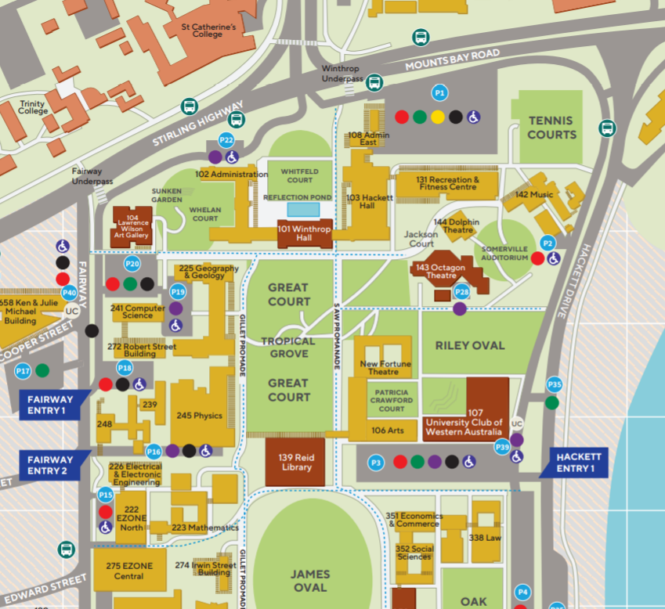
G18 right off foyer, Physics Building

