Early Childhood News – February 2025
A big friendly wave to all working in Early Childhood from the AISWA EC Team. We know from your calls, emails and request that school is back in full swing. I hope that it is a swing that is moving backwards and forth freely, and not stuck in the side of challenges and problems. The other side of the swing arc is often full of classrooms full of joyous children, communities of reassured parents, and teachers overflowing with creativity and connection.
Please remember that our Early Childhood team are here to help. This might be ongoing support for an early career teacher, support with planning documents, a chat about early childhood pedagogy, or ideas for supporting behaviour.
New Team Member
A big welcome to Debbie Bolton to the AISWA Early Childhood Team. Many of you will know Debbie well through her leadership of the Junior School at Carmel or her participation in many of the AISWA EC projects and publications. Deb will manage some of our targeted projects and is available to support schools in National Quality Standards, Early Childhood pedagogy and leadership. Debbie is also available to mentor early career teachers and early childhood leaders.
Small Scale Grants
Applications for small scale grants were processed and approved late 2024. Payments were made to all schools in mid-December. This means that your project is fully funded and ready to be implemented. If you require a copy of your project application, please contact Janelle. If you require confirmation of payment please chat first to your business manager.
On Entry

The On-Entry Assessment Period has officially begun, and we're here to lend a helping hand every step of the way! Our dedicated Early Childhood team is ready and eager to support all our member schools throughout this process.
On-entry Assessment Period
Portal opens week 3 (17th February 2025)
Assessments should be completed between weeks 3-6 (unless you are waiting for the census data to upload, then it will be weeks 4-6)
Portal closes week 8 (21st March 2025)
On Entry Assessment Training is available on the AISWA Online Learning platform from Tuesday 16th January 2025. Please register here.
Deb Bolton will be the senior consultant for On-entry Assessment in 2025, with Janelle Dickinson supporting you with any administration needs and technical difficulties. Please find their contact details below:
Deb Bolton – dbolton@ais.wa.edu.au
Janelle Dickinson – jdickinson@ais.wa.edu.au or 9441 1664
QA 5 - Relationships with Children
‘The start of a new year, and the opportunity to welcome new children and families into an early childhood education and care (ECEC) service provides a unique chance for educators to focus on relational pedagogy.’
Click here a short article reminding us of the importance of developing relationships at the start of the year Relational Pedagogy Resource.
AISWA Publications
The online bookstore has a range of publications that showcase the inspiring work of teachers in AISWA schools.
Professional Learning:
Maker Space
We have spaced across the year a number of afterschool STEM Maker Space events. Our first for the year, April 2nd will be held at AISWA with support from Remida and focuses on loose parts and Recycled Construction. This will be a fun, creative afternoon leaving you inspired with ideas for implementation.
T.A.L.K Workshop
Enhancing Oral Language and Pre-Literacy Skills - Kindy-Pre Kindy. Strong Oral Language is essential for children to become successful readers and writers. This PL is led by our very talented and experienced AISWA EC Consultant Lynne McCarney. Lynne’s workshops are always brimming with ideas and activities and useful resources.
Wendy Gorman - Manager - Support with policy, regulations and early childhood, PRA funding.
Lynne McCarney - Consultant - Support for play groups, Early Literacy, Behaviour guidance.
Melissa Kennedy - Consultant - Support for remote schools, Early Childhood targeted projects.
Debbie Bolton - Consultant - Support for NQS, Pedagogy and Leadership.
Janelle Dickinson - EC Support Officer - On entry assessment, Early Childhood administration.
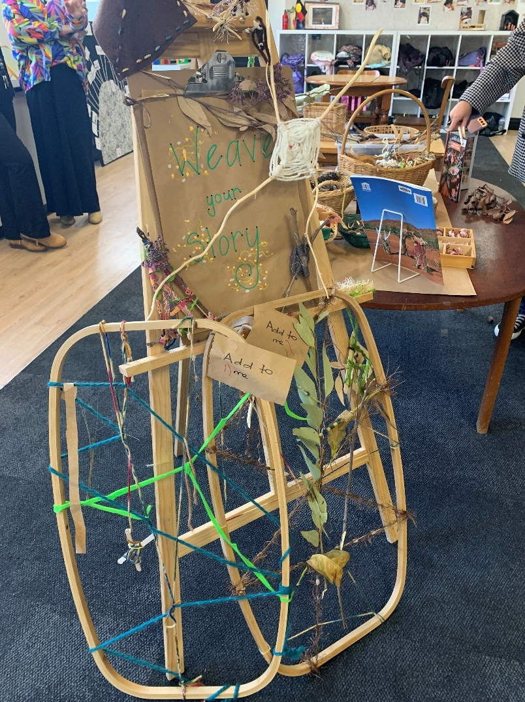
Photo credit: Ngutu College, SA

