**Early Childhood News – January 2025**

Welcome to 2025! The AISWA Early Childhood Team are bouncing with enthusiasm for the year ahead. We hope that you have had a wonderful break and ready for a year of wonder and joy.

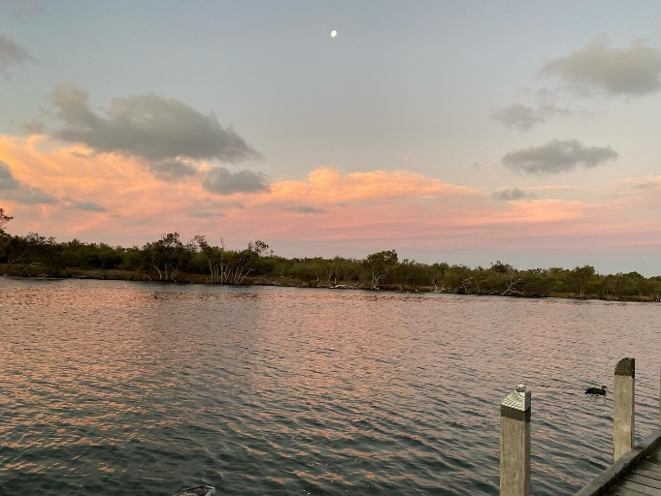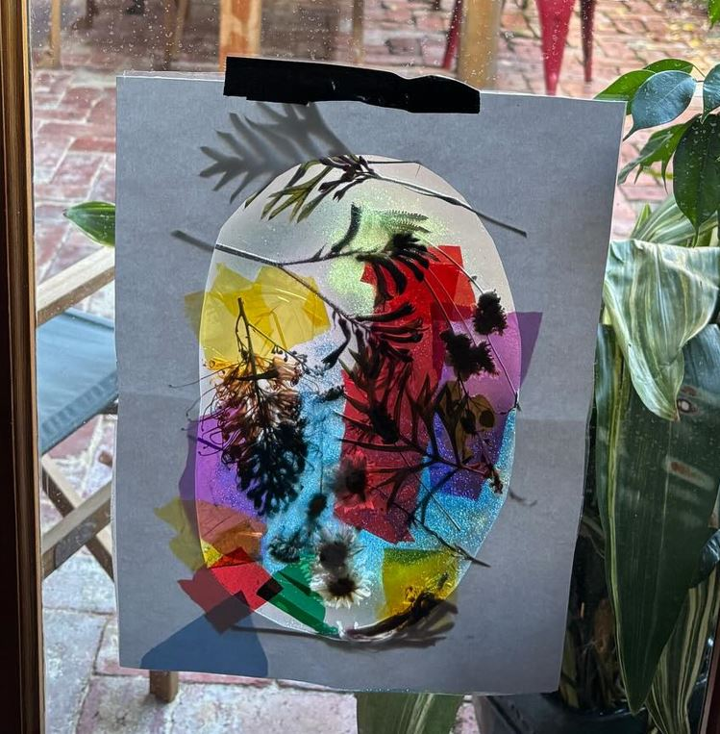

**Transition to School**

*‘An understanding of children and families funds of knowledge and identity helps teachers select appropriate materials and connect curriculum content to children’s culture, identity and experience’*Our [Transitions](https://ro.ecu.edu.au/ecuworks2022-2026/2523/)to school report has excellent ideas on how to make the transition to school smooth and calm  for children, families and educators.

* Develop a playlist that features each child’s favourite song. Use your playlists during transition times such as pack away, eating lunch or for a group sing along.
* Send home social stories about  aspects of school day for families to share together. E.g eating lunch,
* Encourage specialists to come to the children’s classroom for the first few weeks rather than the children moving. Developing a safe and secure base is important in the early weeks.
* Gather information about the child and family and reflect this knowledge in your planning by using this template - [All About My Child 2025.pdf](https://www.ais.wa.edu.au/sites/default/files/basic_page_files/All%20About%20My%20Child%202025.pdf)

**Toileting**

As children transition into a new classroom or begin school the new routine and location often toileting issues arise. We have a number of useful [resources](https://www.ais.wa.edu.au/toileting) available on our website. We are also available for a chat via the phone. We know that this is issue is stressful for all and often talking it through is helpful.

**Playgroups**

A new focus for our Early Childhood team in 2025 is supporting prior to school early childhood education such as prekindergarten and playgroups.  We are hosting a series of network meetings for play group leaders.

Registration is via Eventbrite - [Playgroup network](https://aus01.safelinks.protection.outlook.com/?url=https%3A%2F%2Fwww.eventbrite.com%2Fe%2Faiswa-playgroup-leader-network-meeting-with-joanne-readman-tickets-1096914373419%3Faff%3Doddtdtcreatoror&data=05%7C02%7Cwgorman%40ais.wa.edu.au%7C7c080f557a12414852ed08dd39d158a3%7C72dcc376ad104616a416cd3c66a45c39%7C0%7C0%7C638730293503283987%7CUnknown%7CTWFpbGZsb3d8eyJFbXB0eU1hcGkiOnRydWUsIlYiOiIwLjAuMDAwMCIsIlAiOiJXaW4zMiIsIkFOIjoiTWFpbCIsIldUIjoyfQ%3D%3D%7C0%7C%7C%7C&sdata=Bl1vITwD%2FKsN8%2FEo2Vy%2BBGzsp2V61jY6q%2BCjyc6kNjU%3D&reserved=0). Please contact [Lynne McCarney](mailto:lmccarney@ais.wa.edu.au) with any questions.

Playgroup leaders are invited to join our[Facebook group](https://fb.me/g/7xeHF8Nso/TJsaVITL) (Playgroup Leaders in Independent Schools WA)

**Curriculum Guides**

Looking for our A3 one page curriculum overviews, you will find these on the AISWA website [here](https://www.ais.wa.edu.au/australian-curriculum).

**Conference Sponsorship**

The [Early Childhood Australia Conference](https://www.ecaconference.com.au/2025/) will be held in Perth this year, October 1st – 4th. AISWA Early Childhood will offer a limited number of sponsored places to attend the conference. This will also include travel assistance for remote and regional schools. Information about how to apply will be provided in future newsletters.

**Professional Learning Calendar**

The AISWA Professional Learning calendar is now live and ready for registrations.

Completely New PL:

* [STEM Makerspace](https://www.ais.wa.edu.au/event/stem-maker-space-taster-recyclyed-construction-and-loose-parts)(one per term)
* TALK Workshop - Enhancing Oral Language [Kindy and Pre-kindy](https://www.ais.wa.edu.au/event/talk-workshop-enhancing-oral-language-and-pre-literacy-skills)
* TALK Workshop - Enhancing Oral Language [PP and Year 2](https://www.ais.wa.edu.au/event/talk-workshop-enhancing-oral-language-and-pre-literacy-skills-0)
* [Reconnecting with Reggio Emilia](https://www.ais.wa.edu.au/event/reconnecting-reggio-emilia-workshop-kirsty-liljegren) - Kirsty Liljegren

New PL building on from 2024 themes:

* [Education Assistants Term One](https://www.ais.wa.edu.au/event/education-assistant-pl-day-2025) (this PL is repeated throughout the year)
* [Literacy Bites](https://www.ais.wa.edu.au/event/literacy-bites) (one per term)
* [Designing Powerful Journeys of Inquiry](https://www.ais.wa.edu.au/event/designing-powerful-journeys-inquiry-and-k-6-learners-kath-murdoch-0) - Kath Murdoch

**Early Childhood Team**

Our team is a little smaller as we start the year however recruiting for additional consultants is underway. As soon as the process is finalised we will introduce the new team member/s.

We welcome inquiries from you on any early childhood matter via phone or email. Feel free to make contact with any of the team or for more specialised support see below.

**Wendy Gorman - Manager -** Support with policy, regulations and early childhood, PRA funding.

**Lynne McCarney - Consultant** - Support for play groups, Early Literacy, Behaviour guidance.

**Melissa Kennedy - Consultant -**Support for remote schools, Early Childhood targeted projects.

**Janelle Dickinson - EC Support Officer** - On entry assessment, Early Childhood administration