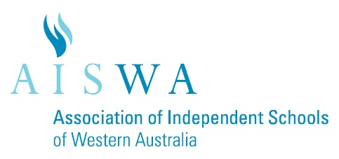
AISWA Heads of Mathematics Network Meeting
Wed 15th November 12.00-3.30pm
Hale School
Chairperson: Ray Hill

Agenda:

Lunch | 12.00
Welcome and Introductions | 12.30
2017 WACE Exams – Discussion on Applications, Methods, and Specialist WACE Exams | 12.35
Mathspathway - Presentation | 1.35
Break/Networking | 2.00
Textbooks or Paperless – Are schools still using texts? Has technology replaced the Maths text book for good? | 2.15
STEM – What is happening in your school? What projects are working? Any good industry links with a Maths twist? | 2.30
Middle/Senior School – How are Maths teachers employed at your school and what is best practice? | 2.45
Other items | 3.00
Venue for Next meeting and agenda items | 3.15
Close – Please complete the sign-in sheet | 3.30

AISWA Heads of Mathematics Network 2018 ??

Term 1 Mon 5 March, 12.00-3.30 TBC
Term 2 Tues 29 May, 9.00-3.30 (at CEO – a joint network meeting)
Term 3 Wed 22 August, 12.00-3.30 TBC
Term 4 Thurs 1 November, 12.00-3.30 TBC

