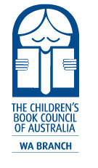 |  |  | 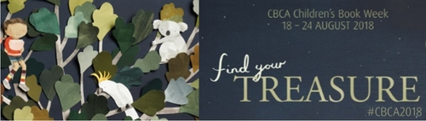
2018 CBCA Book Week Opening and Dinner
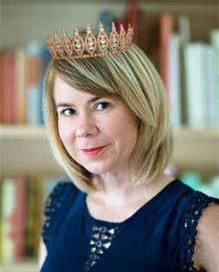 |  | Straight from the red carpet of Hollywood’s Daytime Emmys  we welcome guest speaker  AJ Betts,  WA author and our own living treasure!  AJ’s third novel, Zac & Mia, a story inspired by her teaching experiences at Princess Margaret Hospital, was recently adapted for television by Awesomeness TV.
Friday 17th August 2018
Ambrose Estate
Wembley Golf Course
200 The Boulevard
Wembley Downs
6.30pm for a 7.00pm start
Costume theme (optional): Hollywood glamour
Members @ $70.00 Non-members @ $80.00
includes welcome drink – red, white, bubbles or soft
three course meal with tea and coffee
other drinks on consumption from the bar
Bookings open now: https://www.trybooking.com/WIFC
RSVP: by Monday 6th August, 2018.
Special requests: Contact Sally Woffenden at swoffen@iinet.net.au
to discuss dietary needs or seating arrangements.
Announcement of the
Muriel Barwell Award
for Distinguished Service to Children’s Literature
Join us for an evening of entertainment, conversation, delicious food, amazing raffles, door prizes and costume fun as we celebrate the
Book of the Year winners and hear about AJ’s Hollywood exploits.
Celebrate and glam up in your diamonds and pearls
bring your silk ties, top hats and tiaras for a whirl!

